**Name: JOMOL R K**

**Roll No:09**

**Batch: S2 MCA B**

**Date:8/04/22**

**ADVANCED DATABASE MANAGEMENT LAB**

**Experiment No.: 3**

**Aim**

To familiarize DDL Commands- ALTER, DROP,TRUNCATE,RENAME **Questions**

1.Create a table emp with attributes empno number(4)as primary key, ename char(10),hiredate,  salary, commission

insert 5 rows of data

|  |  |  |  |  |
| --- | --- | --- | --- | --- |
| 101 | Ramesh | 17-Jan  1980 | 5000 |  |
| 102 | Ajay | 05-Jul  1985 | 5000 | 500 |
| 103 | Ravi | 12-Aug  1981 | 1500 |  |
| 104 | Nikesh | 03-Mar  1983 | 3000 | 700 |
| 105 | Ravi | 05-jul  1985 | 3000 |  |

2.Modifying the structure of tables

a.Add new columns: sal number(7,2)

b.Dropping a column from a table: sal

c.Modifying existing column :ename varchar2(15)

d.Renaming the tables: emp to emp1

e.truncating the tables:emp1

f.Destroying tables:emp

3.Create a table stud with sname varchar2(20) primary key , rollno number(10) not null,dob  date not null

4.Create a table student as regno number (6), mark number (3) check constraint (mark >=0 and  mark

<=100));

5.Create a table cust with(custid number(6) constraint unique, name char(10)

**PROCEDURE:**

1. CREATE TABLE EMPTB (EMPNO numeric(4) PRIMARY KEY,ENAME VARCHAR(10),hiredate Date, salary int,commission int);

INSERT INTO EMPTB (EMPNO,ENAME,hiredate,salary,commission)VALUES(101,"Ramesh","1980-01-17",5000,0 );

INSERT INTO EMPTB (EMPNO,ENAME,hiredate,salary,commission)VALUES(102,"Ajay","1985-06-05",5000,500 );

INSERT INTO EMPTB (EMPNO,ENAME,hiredate,salary,commission)VALUES(103,"Ravi","1981-07-12",1500,0 );

INSERT INTO EMPTB (EMPNO,ENAME,hiredate,salary,commission)VALUES(104,"Nikesh","1983-03-03",3000,700 );

INSERT INTO EMPTB (EMPNO,ENAME,hiredate,salary,commission)VALUES(105,"Ravi","1985-06-05",3000,0 );

SELECT * FROM EMPTB;

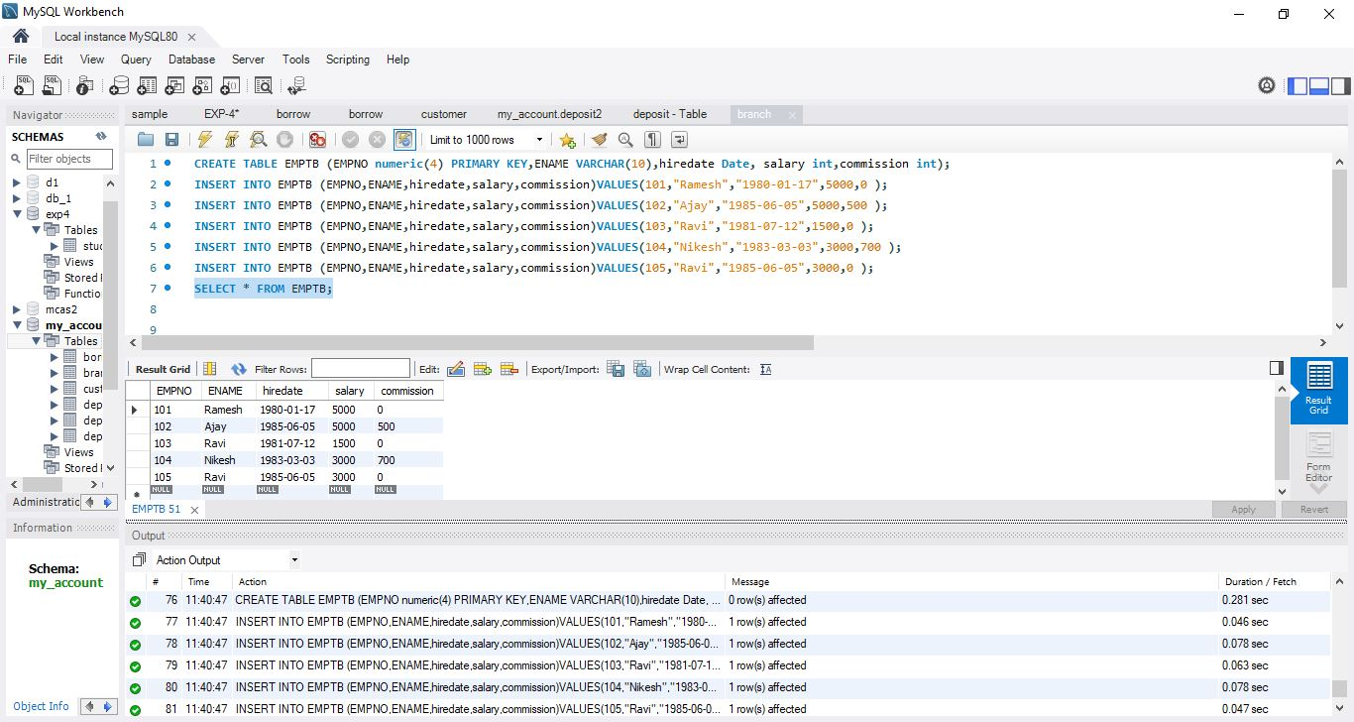

2. a)ALTER TABLE EMPTB ADD sal int;

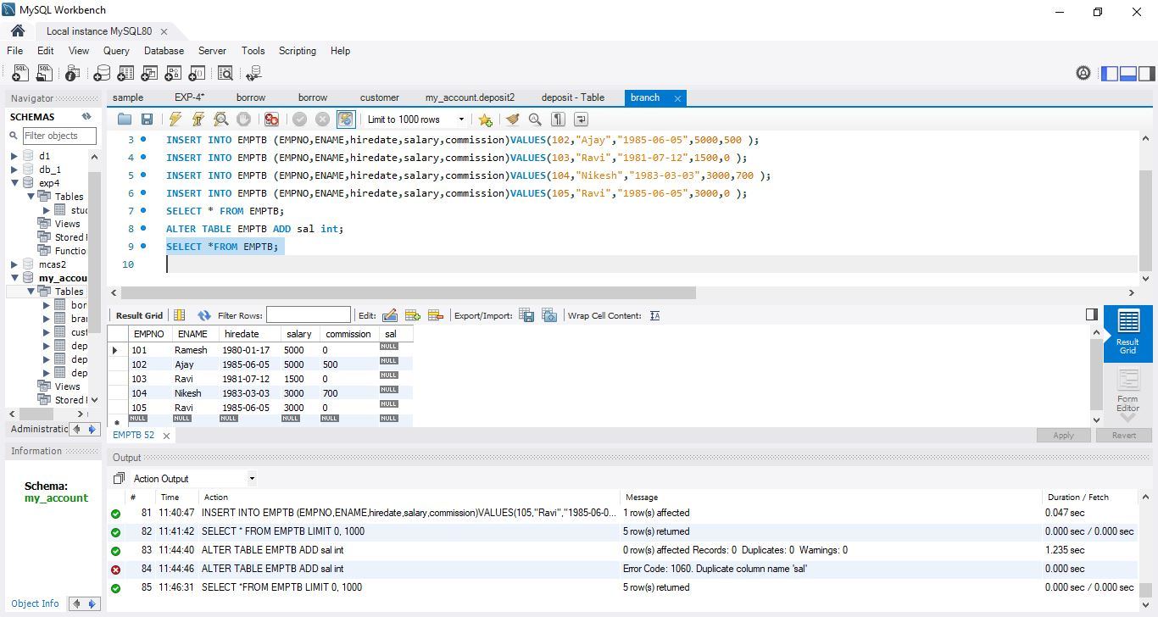

b) ALTER TABLE EMPTB DROP COLUMN sal;

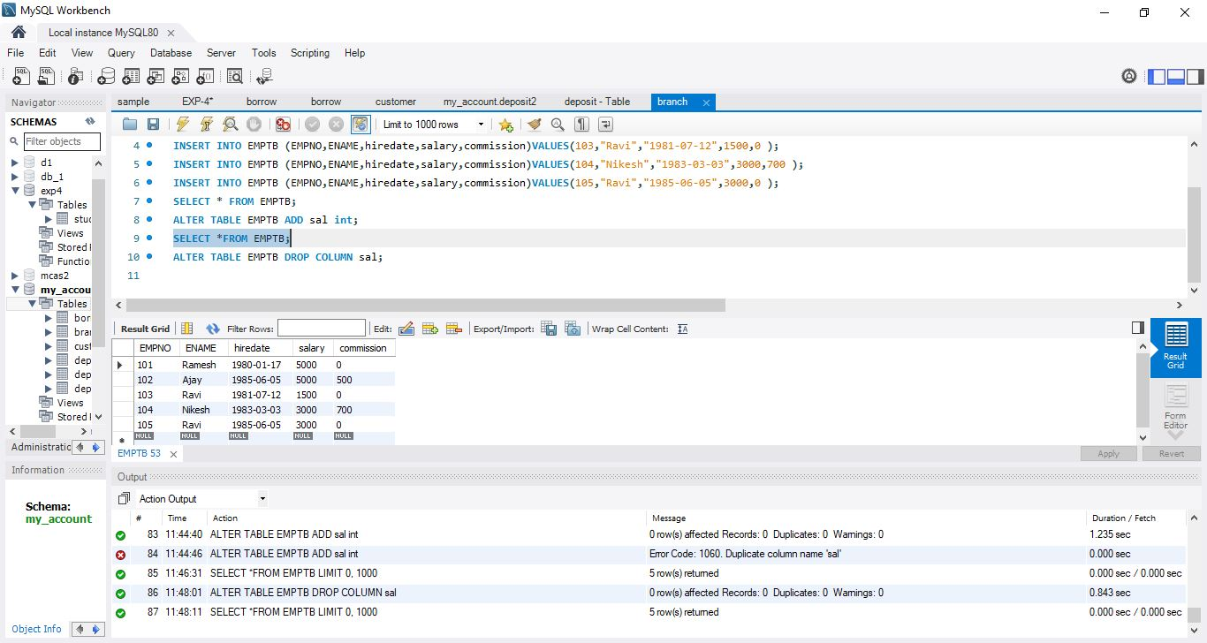

c) ALTER TABLE EMPTB MODIFY ENAME VARCHAR(15);

d) TRUNCATE TABLE EMP1;

e) DROP TABLE EMP1;

3. CREATE TABLE STUD(SNAME VARCHAR(20) PRIMARY KEY,ROLLNO NUMERIC(10) NOT NULL,DOB DATE NOT NULL);

SELECT * FROM STUD;

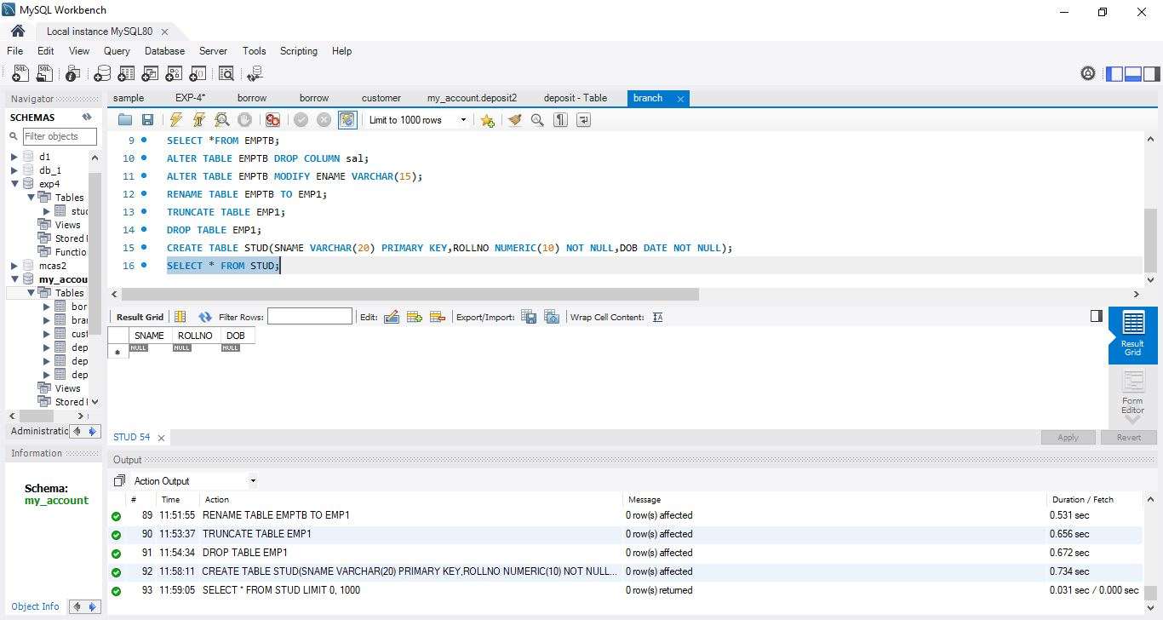

4.CREATE TABLE STUDENT1(REGNO INT,MARK INT constraint C check (MARK>=0 AND MARK <=100));

SELECT*FROM STUDENT1; 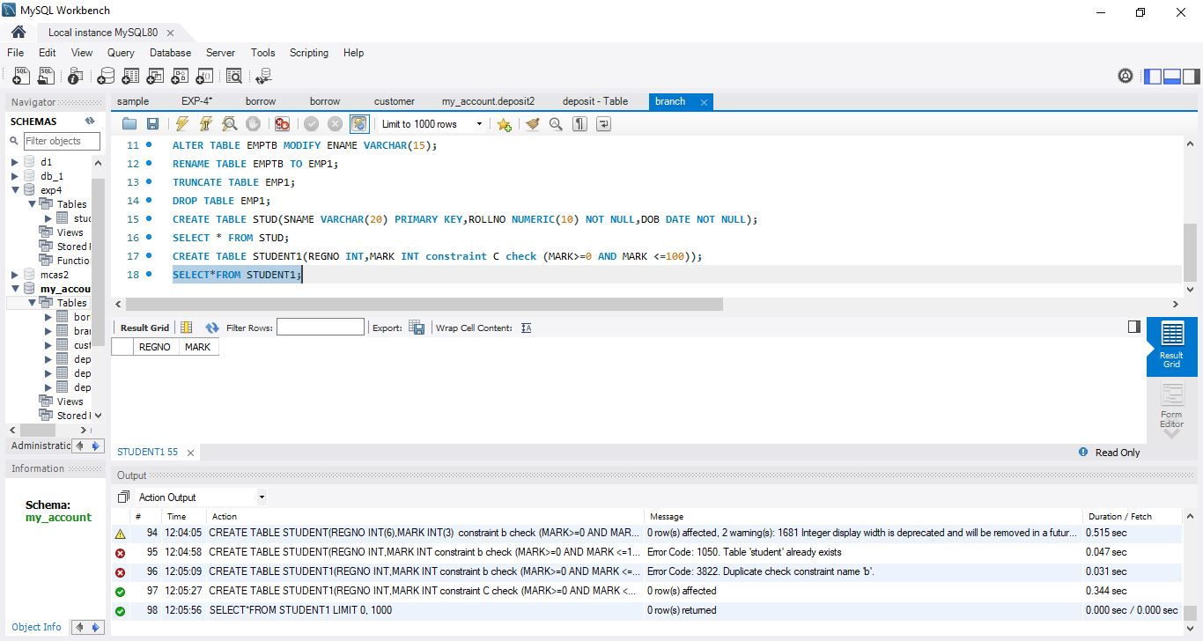

5.CREATE TABLE CUST (CUSTID NUMERIC (6) UNIQUE ,NAME VARCHAR(10));

SELECT * FROM CUST;

